NFC Attendance logger

SeS |ESILV

SES-PROJEcT-2015

David Dupuis and Thomas ZEllner

2015

Table des matières

1. INTRODUCTION 2

2. THE IDEA 2

3. THE DEVELOPMENT 2

4. THE CHALLENGES 6

5. THE DEMO 7

6. THE FUTURE 8

7. CONCLUSION 8

# INTRODUCTION

Welcome to Sensors and Embedded Systems class. The purpose of this course is to gather the general knowledge around embedded systems to discover this world and learn how to get started in it.

During the course we discovered the idea behind communication protocols, embedded systems, embedded languages and programming embedded systems etc... We also learned about the Arduino and the Raspberry Pi more specifically.

By the end of our course we were required to complete a class project in small groups to show our teachers what we had learned regarding this class.

For this project Thomas ZELLNER and myself (David DUPUIS) got together to construct a prototype for a NFC card reader attendance logger.

Our project involved fetching data from a student card using an NFC reader and storing this information in a local database on a Raspberry Pi 2.

# THE IDEA

The idea behind the project is to allow students to validate their attendance to a class simply by scanning their student cards on an embedded device. This device would be set to a specific classroom and would confirm that the student was present in class at a specific time.

Only the student with his student id would be able to “mark” himself as being present. Students wouldn’t be able to sign for other students and teachers wouldn’t have to worry about taking care of the attendance system.

# THE DEVELOPMENT

To develop this project we chose to use different systems.

We would need a Raspberry Pi (in our case a Raspberry Pi 2), a NFC card reader, a student id and a computer to connect the Pi to.

We chose the Raspberry Pi because it would allow us to store the information in the local database. In addition we knew (more or less) how to install the sufficient libraries in order to use the NFC card reader.

For the NFC card reader we chose the u122c as we did not want to worry about electrical wiring and simply wanted to be able to plug the card reader to the Pi via USB.

We were looking forward to developing a life like prototype. With this in mind we considered the possibility of developing a web interface for our attendance logger. However because of our number one challenge we were not able to do this.

Thus we set up the MYSQL database:

* We built our four tables

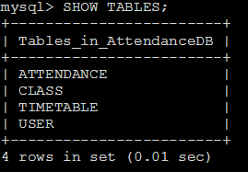

* We made sure we had users:

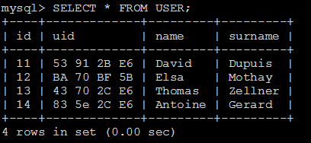

* We added a timetable, in this case user 11 (David Dupuis) has classes 3, 4, 5 and 6.

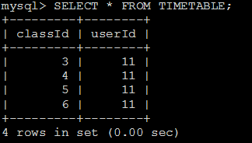

* We added the symbolic classes.

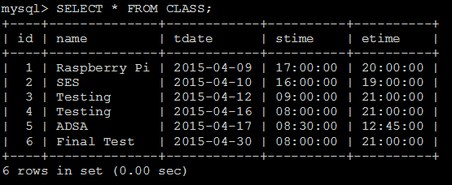

Then we coded the python program that would read the student card and verify the information with the database:

#!usr/bin/python

import MySQLdb, datetime, shlex, subprocess, re, time

db = MySQLdb.connect("localhost","monitor","1234","AttendanceDB")

curs = db.cursor()

output = subprocess.check_output(["nfc-list"])

output = output.decode("utf8")

uid = re.search(r'((\w){2}\s\s){4}',output).group(0).strip().split(" ")

uid = ' '.join(uid).upper()

print ("\n\nUID is: ")

print (uid)

#verifier si l'utilisateur est dans la base

sql = "SELECT * FROM USER WHERE USER.uid = '%s'" % (uid)

try:

curs.execute(sql)

result = curs.fetchone()

except:

print "unable to get info from DB"

if result is None:

print("UID non existant, would you like to add user?")

name = raw_input("Please enter your name: ")

lastname = raw_input("Please enter your surname: ")

s = "Thank you, your name is: %s, your surname is %s" % (name,lastname)

print(s)

sql = "INSERT INTO USER (uid,name,surname) VALUES ('%s','%s','%s')" % (uid,name,lastname)

try:

curs.execute(sql)

db.commit()

except:

print "Unable to add user to DB"

db.rollback()

sql2 = "SELECT * FROM USER"

try:

curs.execute(sql2)

results = curs.fetchall()

for row in results:

id = row[0]

uid = row[1]

name = row[2]

surname = row[3]

print "id = %d, uid = %s, name = %s, surname = %s" % (id, uid, name, surname)

except:

print "Unable to get user array"

userId = result[0]

userUID = result[1]

userName = result[2]

userSurname = result[3]

print "\n\nYour info: id = %d, uid = %s, name = %s, surname = %s" % (userId,userUID,userName, userSurname)

date = datetime.date.today()

time = datetime.datetime.now().time()

print "CURRENT DATE: "

print date

print "CURRENT TIME: "

print time

print "\n"

#get classes that have todays date and time

sql3 = "SELECT * FROM CLASS WHERE tdate = '%s' AND '%s' >= stime AND etime >= '%s'" % (date.strftime('%Y-%m-%d'),time.strftime('%H:%M:%S'),time.strftime('%H:%M:%S'))

try:

curs.execute(sql3)

result2 = curs.fetchone()

except:

print "Error: " + sql3

if result2 is None:

print "There are no classes at this time today!"

else:

classId = result2[0]

className = result2[1]

classDate = result2[2]

classStart = result2[3]

classEnd = result2[4]

sql4 = "SELECT * FROM TIMETABLE WHERE classId = %s AND userId = %s" % (classId, userId)

try:

curs.execute(sql4)

result3 = curs.fetchone()

except:

print "unable to access DB"

if result3 is None:

print "You do not currently have class!"

else:

sql5 = "INSERT INTO ATTENDANCE VALUES(%d,%d)" % (classId,userId)

try:

curs.execute(sql5)

print userName + " " + userSurname + " is noted as PRESENT in class: " + className + " date: "

print classDate

print " Starting at: "

print classStart

print " Ending at: "

print classEnd

except:

print "unable to insert presence in attendance table"

db.close()

# THE CHALLENGES

The NFC card reader was our biggest challenge. Of course we had to get one. To do this we bought the NFC card reader in order to not have to worry about who would lend us one and so that we would have one to work with as soon as possible.

The most challenging aspect of the NFC card reader was to install the necessary library on the Raspberry Pi. This took us too much time and slowed us down. Only a quick hack at the last moment enabled us to get it working.

# THE DEMO

For the demo we execute the necessary command in the Raspberry Pi command line: “python NFC.py”.

If the user has not been entered into the database then the program notices it and asks us to enter the user in the database:

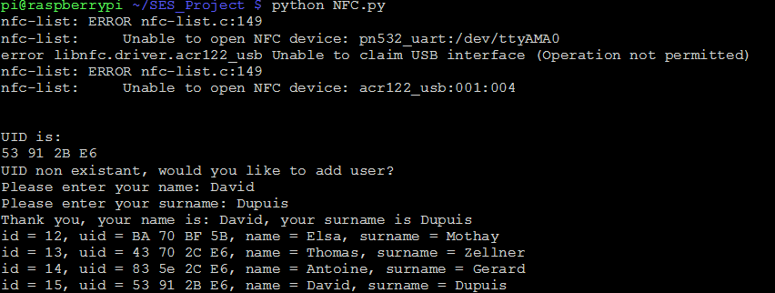

If the user is part of the database then the script checks if he has class and notes his presence inside the attendance table.

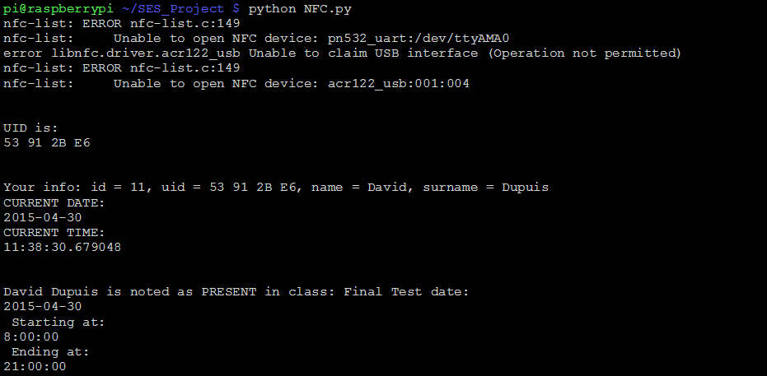

This is then visible in the database attendance table:

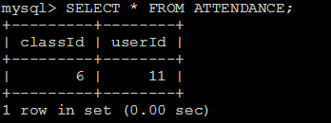

# THE FUTURE

In the future we could expect to program a more advanced NFC attendance logger. It could be fixed in a 3D printed box and plugged to the wall and the schools WIFI. Students would enter a class room, scan their student cards and be noted as present in class.

Immediately a person from the school administration could visualize the student presence in class from a dedicated website. The administration could add a class and remove students from the necessary attendance system, etc… The web interface would allow the administrator to manipulate the database information outside of the MYSQL command line.

Another device could be built with a screen as an interface that would allow students at the entrance of the building to scan their student cards and find out what classes they have and in which classroom they have class.

This system is also interesting as it could be fail proof if the data is correlated with the data of the student entering and leaving the school. As we all know we need our student id to enter and leave the school. If a student did not enter the school and validated his presence or if he validated his presence and left before the given time then it means there has been fraudulent behavior on the student’s side.

# CONCLUSION

To conclude, we can say that Thomas and I have learned enormously about embedded systems and using the NFC card reader and the Raspberry Pi.

We have learned how to use the Linux commands to navigate and reconfigure the Pi.

We have learned how to install the NFC library and use it to get the UID of a student card.

We have learned how to set up a database on the Raspberry Pi and how to write a Python script that would allow us to execute our program on the Pi.

We are proud to have done this project and only wish we had more time to finish it. Hopefully we might find this time later on and improve upon it.